PicoRV32 SoC with AXI-Lite + UART — Complete Course Index 2
Course Overview 2
Quick Reference: Lab Commands 2
Sub-module Map 3
Sub-module Documentation 4
Project File Map 4
RTL Source (rtl/) 4
Testbenches (tb/) 4
Firmware (fw/) 5
Synthesis (openlane_design/) 5
Address Map — Definitive Reference 5
SoC Parameters — Quick Reference 5
AXI-Lite Signal Quick Reference 6
CPU-to-AXI Bridge FSM 6
Simulation Output Reference 6
Expected make soc Output 6
Expected make axi_sa Output 7
ASIC Design Notes 7
Interview Preparation Topics 7
RISC-V ISA 7
AXI-Lite 7
UART 8
SoC Integration 8
Firmware 8
Waveform Files Reference 8

PicoRV32 SoC with AXI-Lite + UART — Complete Course Index
Course: Design and Implementation of a RISC-V Based SoC Subsystem
Technology: PicoRV32 (RV32I) + AXI-Lite + UART + Verilator + GTKWave + OpenLane

Course Overview
This course takes you from zero to a complete, ASIC-ready SoC design. You will:
- Understand RISC-V ISA, AXI-Lite protocol, and UART communication
- Implement a full SoC subsystem in Verilog with 9 RTL modules
- Verify each component and the complete system using Verilator simulation
- Write embedded C firmware that runs on the CPU and communicates via UART
- Synthesize the design using Yosys + OpenLane2 for ASIC tape-out readiness

Quick Reference: Lab Commands
Sub-module | Topic | Command
M1 | RISC-V ISA | make pico
M2 | AXI-Lite | make axi_sa
M3 | UART | make uart
M4 | MMI RISC-V + UART | make soc_pico_uart_mem
M5 | RISC-V + AXI | make riscv_axi
M6 | AXI + UART | make axi_uart
M7 | Firmware | make fw
M8 | Full SoC | make soc / make debug_soc
M9 | Waveform | make wave
— | Common | make clean / make synth

Sub-module Map
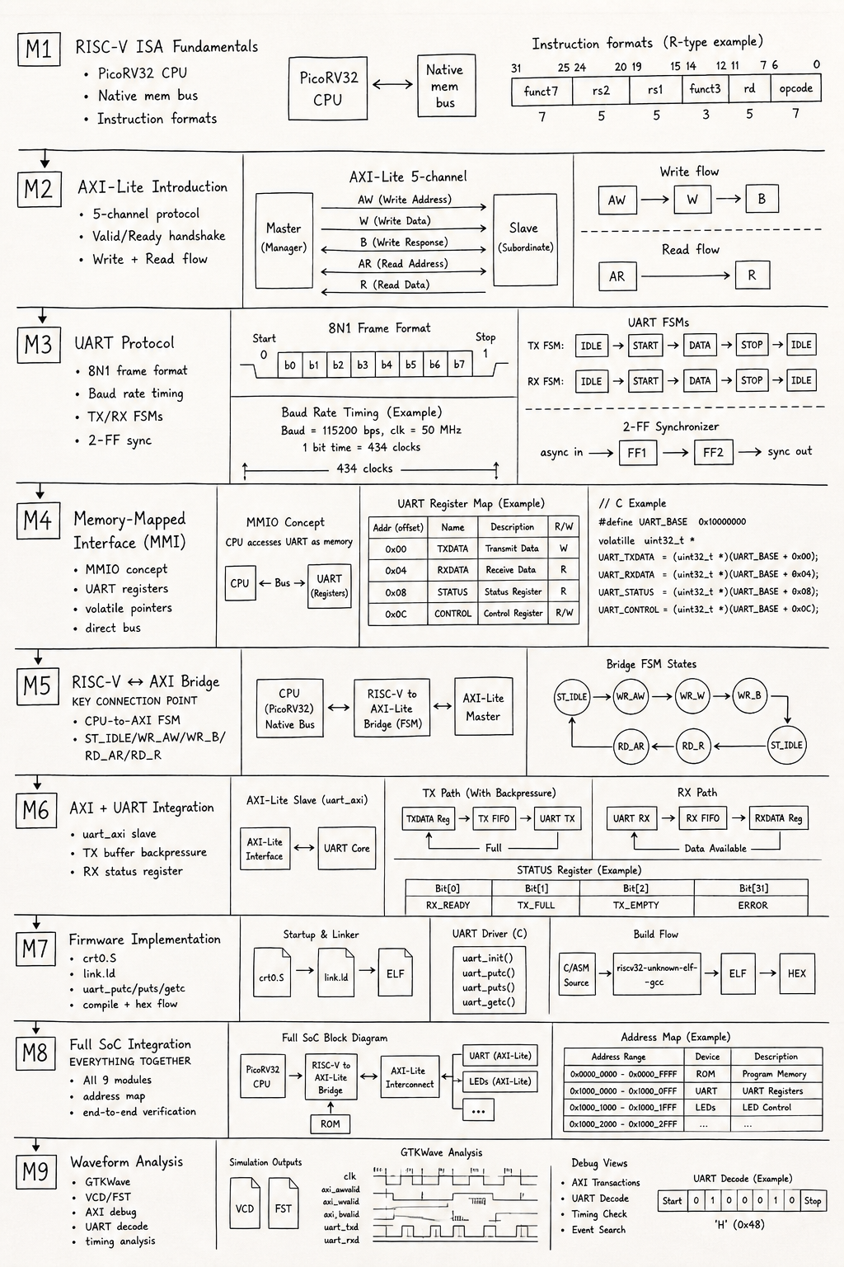s

Sub-module Documentation
SN | Sub-module | Lab Document | Key Lab Command
1 | Fundamentals of RISC-V ISA | Sub-module_1_lab.md | make pico
2 | Introduction to AXI-Lite | Sub-module_2_lab.md | make axi_sa
3 | UART Protocol | Sub-module_3_lab.md | make uart
4 | MMI RISC-V + UART | Sub-module_4_lab.md | make soc_pico_uart_mem
5 | RISC-V AXI Integration | Sub-module_5_lab.md | make riscv_axi
6 | AXI + UART Integration | Sub-module_6_lab.md | make axi_uart
7 | Firmware Implementation | Sub-module_7_lab.md | make fw
8 | Full SoC Integration | Sub-module_8_lab.md | make soc
9 | Waveform Analysis | Sub-module_9_lab.md | make wave

Project File Map

RTL Source (rtl/)
File | Sub-module | Role
picorv32.v | M1/M8 | PicoRV32 CPU — full RV32I implementation
top.v | M5/M8 | SoC top: CPU + bridge + interconnect wiring
axi_lite_interconnect.v | M2/M8 | 1-master, 3-slave AXI-Lite router
axi_decoder.v | M2/M8 | Combinational one-hot address decode
rom.v | M2/M8 | AXI-Lite ROM (sim: readmemh, synth: case)
sram.v | M2/M8 | AXI-Lite SRAM with byte-enable write
uart_axi.v | M6/M8 | UART as AXI-Lite slave (TX buf + RX buf)
uart_tx.v | M3/M6 | 8N1 UART transmitter FSM
uart_rx.v | M3/M6 | 8N1 UART receiver FSM + 2-FF sync
rom.hex | M7/M8 | Firmware binary: generated by make fw

Testbenches (tb/)
File | Sub-module | Tests
tb_top.v | M8/M9 | Full SoC: UART monitor + 10 greetings + PING echo
tb_debug.v | M8/M9 | Verbose debug version of tb_top
tb_axi_lite_standalone.v | M2 | AXI-Lite handshake demo (self-contained)
tb_riscv_axi_lite.v | M5 | CPU-AXI integration demo (self-contained)
tb_axi_lite.v | M6 | AXI master + uart_axi DUT test
tb_axi_lite_master.v | M6 | Reusable AXI master task library
tb_uart_top.v | M3 | UART TX/RX loopback test

Firmware (fw/)
File | Role
main.c | Application: print greeting ×10 + echo loop
crt0.S | Startup: stack setup + call main
link.ld | Memory map: ROM@0x0, SRAM@0x10000
Makefile | compile → link → objcopy → bin2hex
bin2hex.py | Converts binary to 4-wide hex for readmemh
gen_rom_case.py | Generates synthesizable case-ROM from hex
firmware.elf | Pre-built (inspect with riscv32-…-objdump)
firmware.bin | Raw 167-byte binary

Synthesis (openlane_design/)
Goal | Command
Yosys synthesis | make synth
OpenLane2 full flow | make openlane
Synthesis flag | -D SYNTHESIS activates case-ROM path

Address Map — Definitive Reference
Address Range | Peripheral | Slave Index | Bus
0x0000_0000 – 0x0000_FFFF | ROM (firmware) | S0 | AXI-Lite
0x0001_0000 – 0x0001_FFFF | SRAM (data/stack) | S1 | AXI-Lite
0x1000_0000 | UART TX register | S2 | AXI-Lite
0x1000_0004 | UART RX register | S2 | AXI-Lite
0x1000_0008 | UART STATUS register | S2 | AXI-Lite

SoC Parameters — Quick Reference
Parameter | Value | Notes
CPU | PicoRV32 | RV32I, no MUL/DIV/FPU
Clock | 50 MHz | CLK_PERIOD = 20 ns
Boot address | 0x0000_0000 | PROGADDR_RESET
Stack top | 0x0001_00FC | STACKADDR
ROM depth | 2048 words = 8 KB | MEM_DEPTH=2048
SRAM depth | 64 words = 256 B | MEM_DEPTH=64
UART baud | 115200 | BAUD_RATE
CLKS_PER_BIT | 434 | 50 MHz / 115200
UART bit period | 8.68 µs | 1/115200
UART byte + frame | 86.8 µs | 10 bit-periods

AXI-Lite Signal Quick Reference
Channel | Master drives | Slave drives | Direction
Write Address (AW) | AWADDR, AWVALID | AWREADY | M→S
Write Data (W) | WDATA, WSTRB, WVALID | WREADY | M→S
Write Response (B) | BREADY | BRESP, BVALID | S→M
Read Address (AR) | ARADDR, ARVALID | ARREADY | M→S
Read Data (R) | RREADY | RDATA, RRESP, RVALID | S→M
Handshake rule: Transfer occurs at rising clock edge when VALID AND READY = 1.

CPU-to-AXI Bridge FSM
State | Value | Action
ST_IDLE | 3’d0 | Wait for cpu_mem_valid
ST_WR_AW | 3’d1 | Issue AW+W, wait for AW/W handshakes + B response
ST_WR_B | 3’d2 | Wait for B channel (if AW+W already done)
ST_RD_AR | 3’d3 | Issue AR channel, wait for arready
ST_RD_R | 3’d4 | Wait for R data, latch into rdata_r

Simulation Output Reference

Expected make soc Output
--------------------------------------------------
UART SoC Simulation Started
--------------------------------------------------
[ROM] loaded from plusarg: rtl/rom.hex
[TB] UART Monitor Started
[TB] RX byte: H ← Character-by-character from UART TX
...
[TB] Greeting message count = 10
============================================
10 GREETING MESSAGES RECEIVED
UART OUTPUT VERIFIED
============================================
[TB] FIFO flushed - sending command : PING
[TB] RX byte: P
[TB] RX byte: I
[TB] RX byte: N
[TB] RX byte: G
============================================
TEST PASSED
Echo received : PING
============================================

Expected make axi_sa Output
======================================================
AXI-Lite Standalone Testbench (32-bit addr/data)
======================================================
[CHECK] Write Data == Read Data → PASS ✓
SUMMARY : Passed = 1 Failed = 0
======================================================

ASIC Design Notes
Category | Status
initial blocks in RTL | ✅ None (only in testbenches)
Combinational loops | ✅ None
Inferred latches | ✅ All outputs have defined defaults
synthesis path | ✅ Case-ROM in rom.v via -D SYNTHESIS
Yosys synthesis | ✅ make synth runs without fatal errors
OpenLane2 | ✅ make openlane (config in openlane_design/)

Interview Preparation Topics

RISC-V ISA
- What are the 6 RISC-V instruction formats?
- How does the PicoRV32 memory interface work?
- What is the boot sequence of a RISC-V bare-metal system?

AXI-Lite
- Explain the valid/ready handshake with an example
- Why are AW and W channels separate?
- What does WSTRB = 4’h1 mean?
- How does a slave signal backpressure on the write channel?

UART
- Calculate CLKS_PER_BIT for 9600 baud at 25 MHz
- What is the purpose of the 2-FF synchronizer in uart_rx?
- Why sample at the middle of the bit period, not the edge?

SoC Integration
- How does the CPU reading ROM differ from writing to UART at the protocol level?
- What keeps the AXI bridge in ST_WR_AW if the B channel never responds?
- What happens if two masters try to access the AXI slave simultaneously?
- How does a synthesizable ROM differ from an SRAM in RTL?

Firmware
- What does volatile do in embedded C?
- Why is -nostartfiles used in the firmware compilation?
- What does crt0.S do before calling main()?

Waveform Files Reference
VCD/FST File | From | Size | Contents
tb_top.fst | make soc | ~5 MB | Full SoC simulation
tb_top_debug.fst | make debug_soc | ~5 MB | Debug TB version
tb_axi_lite.vcd | make axi_uart | 1.9 MB | AXI-UART module
tb_axi_lite_standalone.vcd | make axi_sa | 3.8 KB | AXI handshake demo
tb_riscv_axi_lite.vcd | make riscv_axi | 3.3 KB | CPU-AXI demo
tb_uart.vcd | make uart | 2.9 MB | UART loopback
tb_picorv32.vcd | make pico | 36 KB | PicoRV32 standalone
tb_mem_soc.vcd | make soc_pico_uart_mem | 142 MB | MMI SoC (direct bus)

